

CSA0902-Programming in Java

CO2 - AT1

Scenario Based Questions

Ashmi P S
192571004

1.Student Mark Analysis
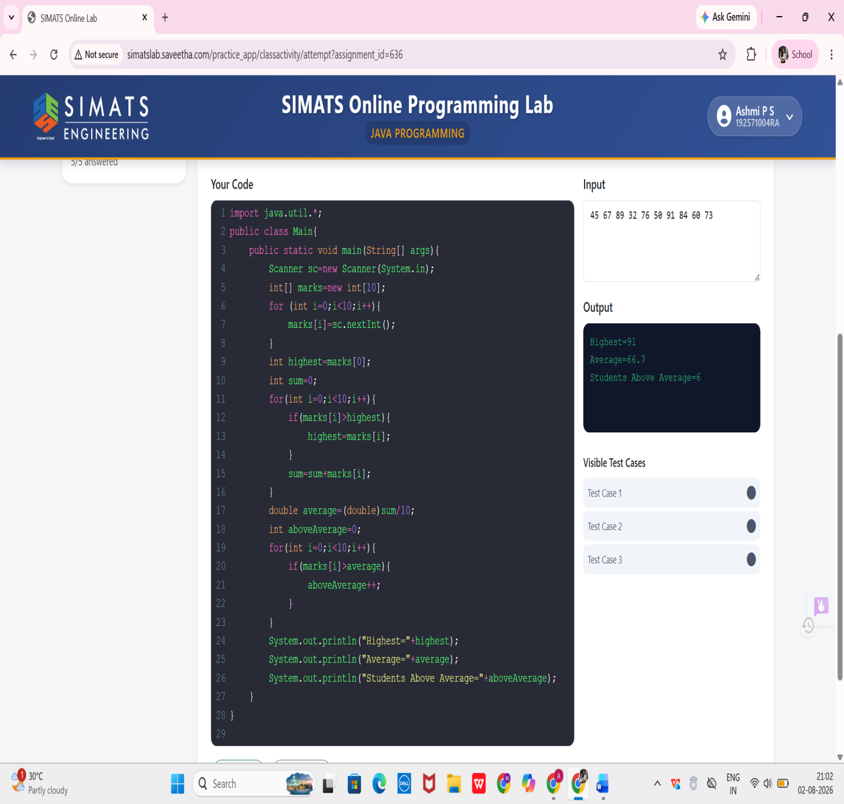

2.Attendance Tracker
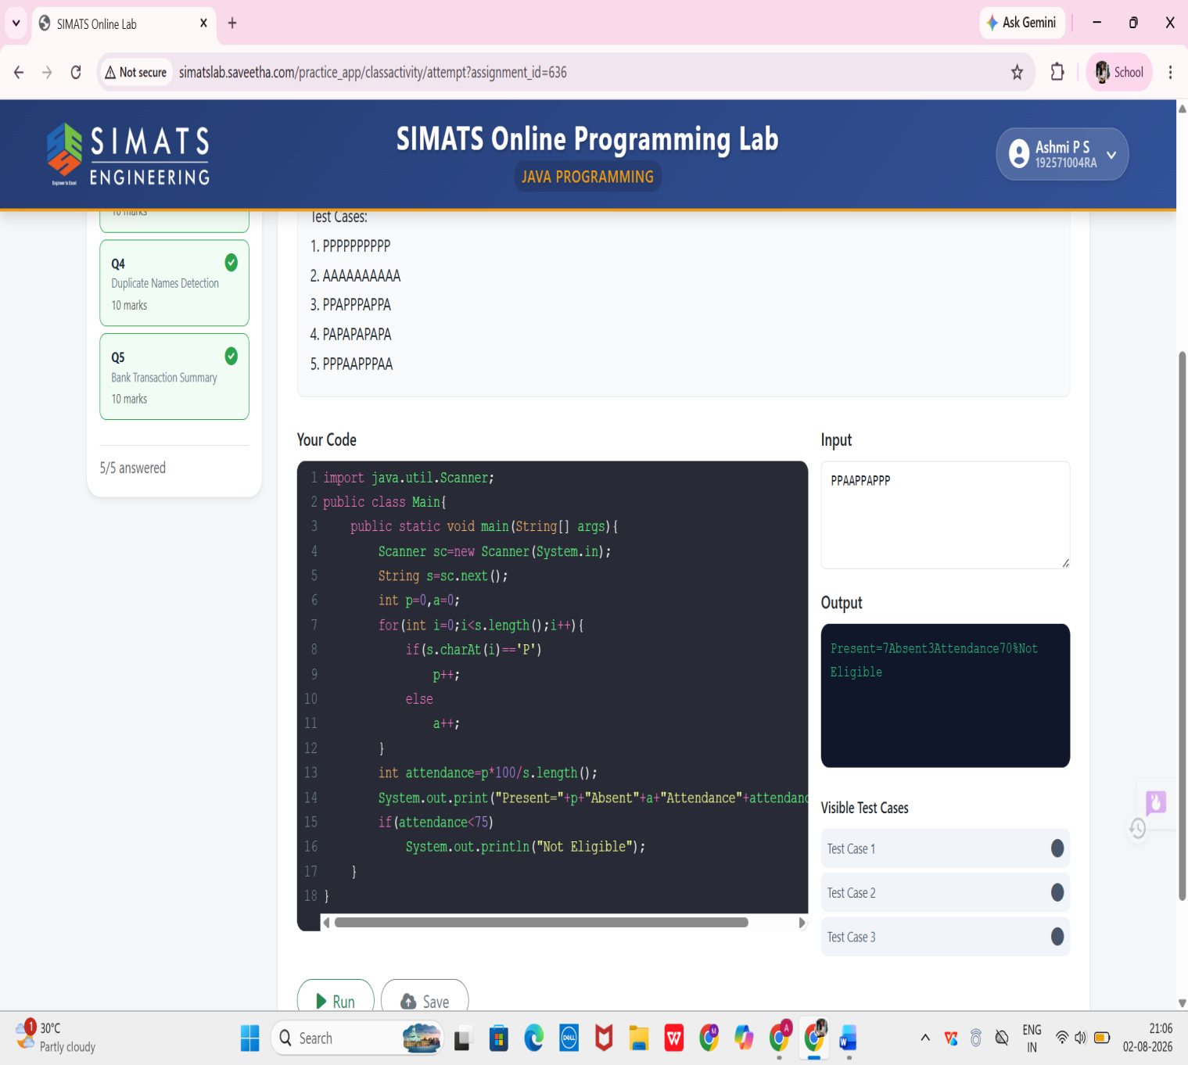

3.Exam Result System
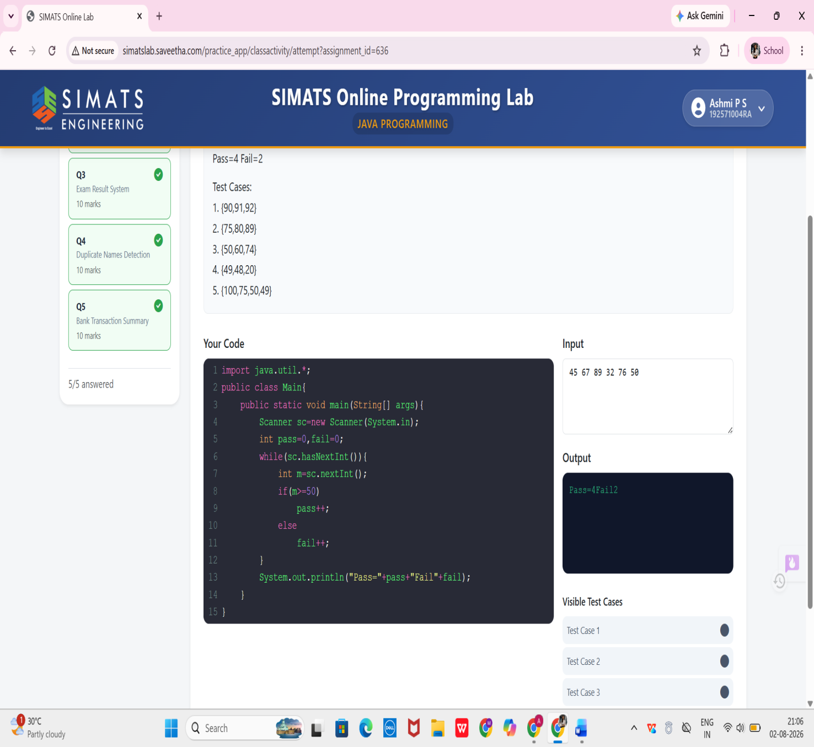

4.Duplicate Names Detection
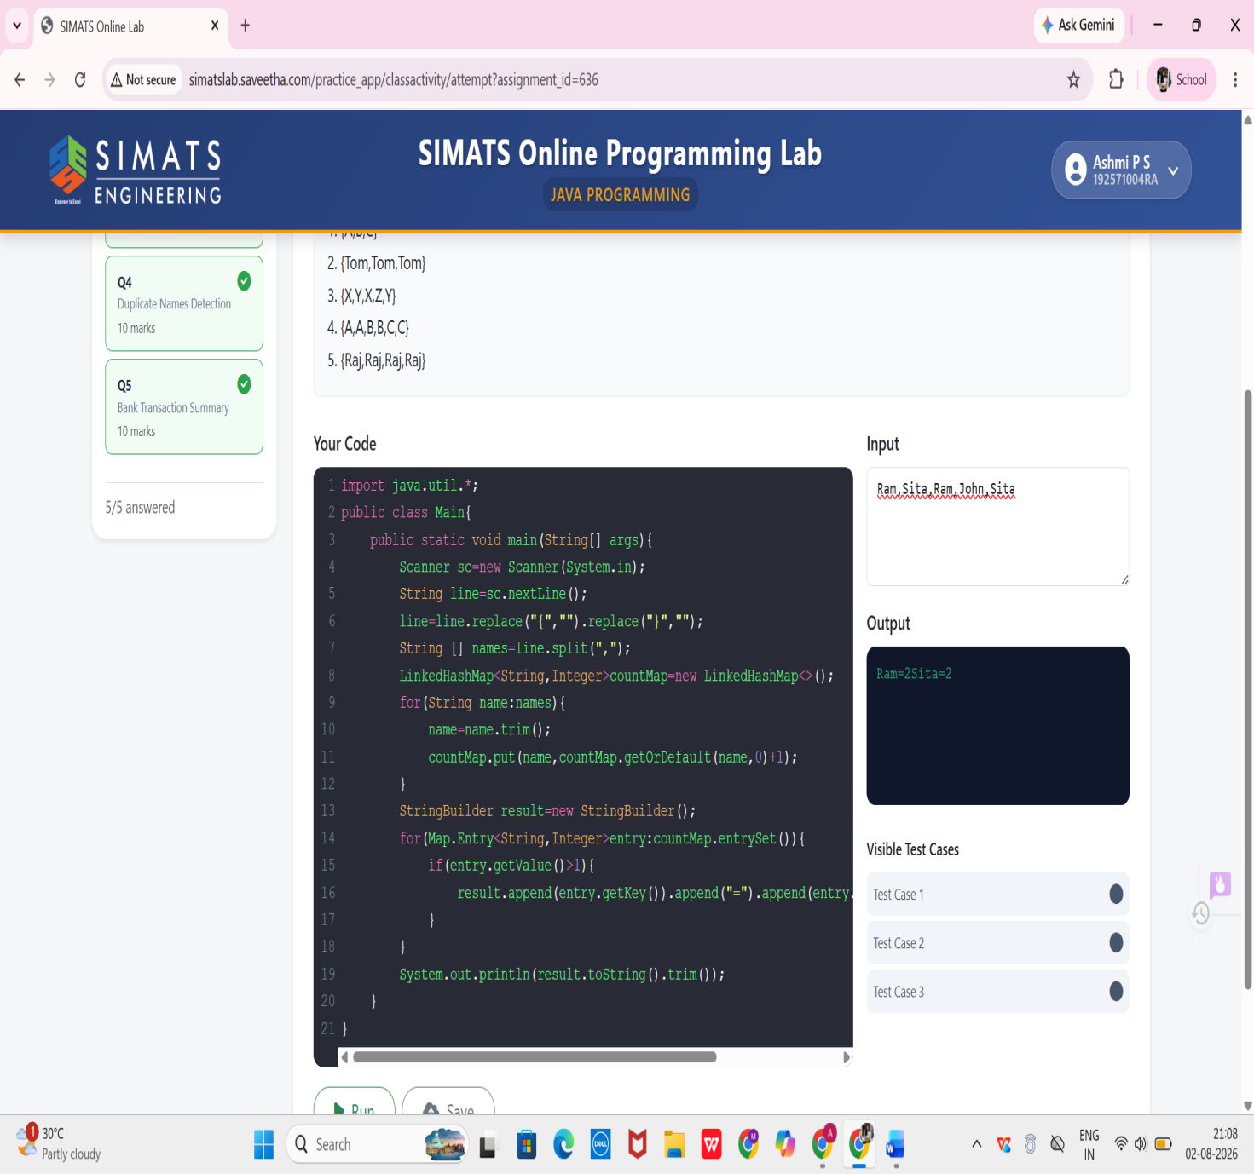

5.Bank Transaction Summary
